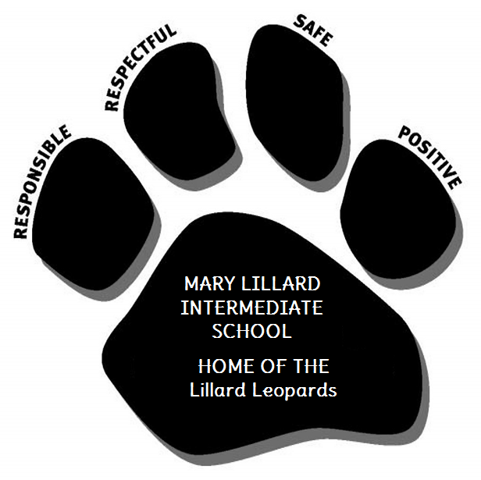

***A Guide for New Students:***

# A SUCCESSFUL START TO A NEW SCHOOL

**This packet belongs to**:\_\_\_\_\_\_\_\_\_\_\_\_\_\_\_\_\_\_\_\_\_\_\_\_\_\_\_\_\_\_\_\_\_\_\_\_\_

**Welcome to**

**Mary Lillard Intermediate School!**

***We are pleased to have you join our school community. We know that starting a new school can be stressful, so we would like to be of assistance to you in making a positive start. Before we start talking to you about school expectations, let’s meet several people who can assist in making a smooth transition.***

Your administrators and teachers can help you with school questions, teacher/student concerns, disciplinary issues, safety concerns, recognition and advice.

M.L.I.S. Administration and Staff

|  |  |
| --- | --- |
| ***ADMINISTRATORS*** | C:\Users\Kathy\AppData\Local\Microsoft\Windows\Temporary Internet Files\Content.IE5\882YU1FX\MC900060324[1].wmf***COUNSELORS*** |
| ***PRINCIPAL: Dr. Herzberg*** |  |
| ***ASSISTANT PRINCIPAL: Ms. Caldwell*** | ***5th GRADE COUNSELOR*: *Ms. Newman*** |
| ***ASSISTANT PRINCIPAL: Mr. Bennett*** | ***6th GRADE COUNSELOR:* *Ms. Pierce*** |

OTHER IMPORTANT PEOPLE YOU SHOULD GET TO KNOW

|  |  |  |
| --- | --- | --- |
|  | **bd06870_School Nurse: Ms. Morgan** | **School Librarian: Ms. Wilson**  **pe00753_** |

My Team Name \_\_\_\_\_\_\_\_\_\_\_\_\_\_\_\_\_\_\_\_\_\_\_\_\_\_\_\_\_\_

My Locker # \_\_\_\_\_\_\_\_\_\_\_\_\_\_\_\_\_\_\_\_\_\_\_\_\_\_\_\_\_\_\_\_\_

My First Academic Teacher’s Name: \_\_\_\_\_\_\_\_\_\_\_\_\_\_\_\_\_\_\_\_\_\_\_\_\_\_\_\_\_\_\_\_

Mary Lillard Intermediate School

***Student Expectations***

We want our students to demonstrate outstanding performance in their academics and social/emotional behaviors. Even though we are unique individuals and learners, the same expectations apply to all of our students. We expect these expectations to be met by all students in school and community settings. The students and adults at Mary Lillard Intermediate School are respectful, responsible, safe and positive.



**The Leopard Affirmation**

1. **I will treat people and property with *respect*.**



1. **I am *responsible* for my actions and will accept consequences for my behavior.**
2. **I will make Mary Lillard Intermediate School a *safe* place by following school procedures.**
3. **I will contribute to a *positive* school environment.**

**The Leopard Code: The 4 B’s**

**Be Respectful Be Responsible Be Safe Be Positive**

***What does it look to be safe, responsible, respectful and positive at Mary Lillard Intermediate School?***

**You will learn to apply the Leopard Code to other settings such as   
the library, bus, computer lab, assemblies, etc.**

|  |  |  |  |  |
| --- | --- | --- | --- | --- |
| ***Setting*** | ***Be Respectful*** | ***Be Responsible*** | ***Be Safe*** | ***Be Positive*** |
| **School-wide** | **-Treat people and property with respect.**  **-Use kind words & actions**  **-Be honest**  **-Wait your turn**  **-Follow adult directions first time given**  **-Listen quietly when someone is speaking** | **- Abide by the MISD Student Code of Conduct**  **-Take proper care of all personal belongings & school equipment**  **-Arrive prepared and on time**  **-Accept consequences for your actions without arguing** | **-Use all equipment & materials appropriately**  **-Keep hands, feet & objects to yourself**  **-Get adult help for accidents, spills, conflicts or other potentially dangerous situations**  **-Stay in designated areas** | **-Take pride in yourself and your environment**  **-Encourage and help others**  **-Respect differences**  **-When you make a mistake or are corrected, reflect on the situation and determine to do better next time** |
| **Classroom** | **-Raise your hand & wait to be acknowledged**  **-Use appropriate language & tone**  **-Respect one another’s personal space** | **-Follow classroom procedures**  **-Be prepared with needed supplies**  **-Complete assignments to the best of your ability**  **-Be an active participant**  **-Arrive to class on time** | **-Keep your hands, feet, and objects to yourself**  **-Use materials for their intended purposes**  **-Get permission to leave your seat**  **-Keep possessions in lockers or safely stowed** | **-Be positive and in control of your actions while encouraging others to do the same**  **-Be an authentic listener**  **-Be an enthusiastic learner**  **- Be open-minded and willing to try new things** |
| **Hallways** | **-Stay self-controlled and to the right**  **-Stop and listen to adults when spoken to**  **-Follow directions first time given**  **-Look at displays, but don’t touch** | **-Use a hall pass**  **-Get materials during passing periods**  **-Keep track of your own materials**  **-Arrive to class on time**  **-Help keep hallways clean and clear** | **-Walk on the right**  **-Keep hands, feet, and objects to yourselves**  **-Stay in your assigned hallways**  **-Use stairs for walking only** | **-Put ups, not put downs**  **-Use good manners**  **-Be helpful**  **-Acknowledge others with a smile or nod** |
| **Cafeteria** | ***-*Follow lunchroom procedures**  **-Sit in your assigned area**  **-Follow adult directions first time given**  **-Use appropriate manners**  **-Use an indoor voice** | **-Keep a clean table area**  **-Keep food and drinks in the cafeteria**  **-Pick up trash**  **-Make healthy choices** | **- Walk quietly with your teacher and class**  **-Wait patiently in line**  **-Sit 4 students per bench**  **-Stay in the cafeteria until you have permission to leave** | **-Focus on the positive**  **-Use kind words to solve problems**  **-Use good manners when speaking to others**  **-Thank the cafeteria workers** |
| **Bathroom** | **-Wait patiently for your turn**  **-Leave when you are finished**  **-Respect one another’s personal space** | **- Wash hands**  **- Clean up after yourself**  **- Throw trash in containers**  **- Return to class promptly** | **-Use bathroom at scheduled times**  **-Use passes for unscheduled breaks**  **-Report problems to an adult**  **-Keep hands, feet, and objects to yourself** | **-Settle problems with kind words**  **-Be mindful of others** |
| **Recess** | **-Follow line-up procedure**  **-Take turns on equipment**  **-Use appropriate language** | **-Pick up your own trash**  **-Wait patiently for turn**  **- Store bags, lunch boxes, etc. in assigned areas** | **-Hands to yourself, unless playing tag**  **- Use only provided equipment appropriately**  **-Stay in assigned areas** | **-Handle disappointment and loss maturely**  **-Encourage others and acknowledge fair play** |

***REWARDING OUR STUDENTS***

We like to catch our students doing the right thing. If you are demonstrating safe, responsible, respectful and positive actions, an adult in the building MAY approach you and hand you a piece of paper like the one below. It’s their way of letting you know that you are doing the right thing!

“LEOPARD BUCKS”

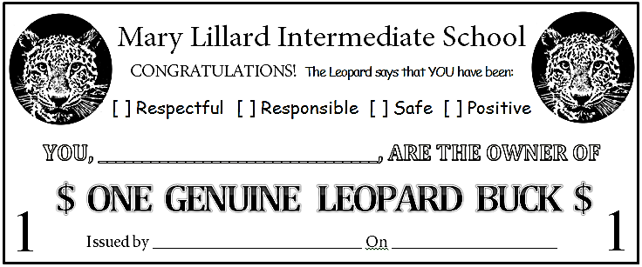

SAMPLE

You will be able to use your Leopard Bucks to buy supplies, personal privileges, hall passes, homework passes, special privileges or activities, and much more!

Each team will develop a menu of items and privileges that students can purchase using Leopard bucks. EXAMPLE:

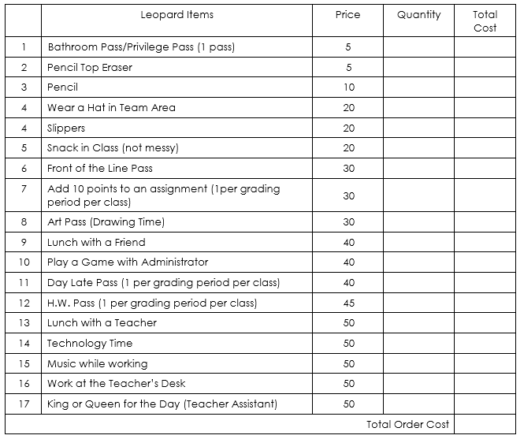

***RESPONSIBILITY CARDS***

In addition to earning Leopard Bucks, students can earn a trust card when they show exemplary academics and conduct while at school.

Each trust card has various privileges that a student can use during the grading period.

Students will be given their trust card at the beginning of the 2nd grading period depending on their achievements from the previous grading period. Students can “level up” their trust card at the end of every grading period based on their achievements.

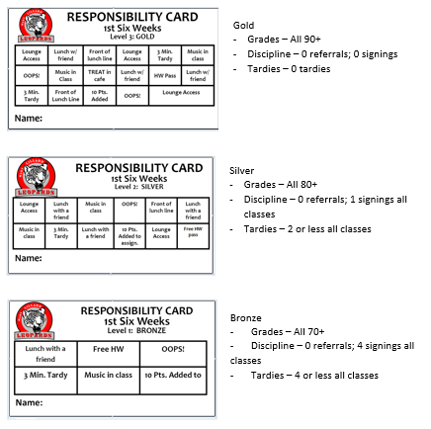

***DISCIPLINE and INTERVENTION***

We recognize that not all students will meet student expectations on a consistent basis. When students make inappropriate choices, they will receive consequences and enter our school discipline process. Consequences will be accompanied by re-teaching of the expected behaviors and student reflection.

**Student Signings & Referrals**

Most students and parents are aware of the “green, yellow, and red” system that is used in many elementary schools. Instead of the tangible green, yellow, and red colors, Lillard teachers redirect students and remind them of the expectations of the classroom. If expectations are still not met, the student will receive a signing. Redirection and teaching of the expectation always happen before a signing is given.

Behavior warranting a classroom signing is defined as:

* Student behavior that persistently disrupts other students’ learning, and/or the role responsibilities of the teacher.
* A student who chooses to consistently disregard an established classroom procedure during class time.
* A student who chooses to be inconsiderate of classmates or staff.

Discipline Hierarchy

1st signing – Written Notice and Parent Contact

2nd signings – Written Notice/Parent Contact and 2 days lunch and recess detention\*

3rd signings – Team Conference/Parent Contact and 1-hour after school detention

4th signings – Office Referral/Parent Contact

\*\*Each team will have a designated recess detention area.

\* \* \* \* \* \* \*

**Report Card Conduct Grades**

E = 0 signings

S = 1 signings

N = 2-3 signings

U = 4 or more signings